Nepal College of Information Technology
Unit Test
Fall 2010
Program: B.E.IT/CE/ELX Time: 2 hrs
Semester: Fall (III) FM: 65
Subject: Engineering Math-III PM: 32
Attempt all questions

1. a. Prove 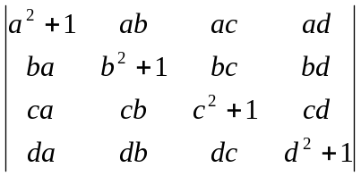=1+a²+b²+c²+d² 8
b. Prove that 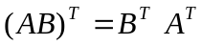 7
OR
Solve x+y-z=9
8y+6z=-6
-2x+4y-6z=40 by Gauss elimination method.
2. a. If A=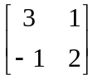 8
Find the value of A²-5A+7I where I is a unit matrix of size 2x2
b. Show that the necessary and sufficient condition for the vector valued function of the scalar variable t to have a constant magnitude is .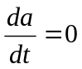 7
3. a. Find the directional derivative of f=xy²+yz³ at P(2,1,-3) in the direction =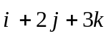 5
b. If 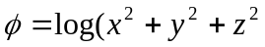), find div(grad) and curl(grad) 5
c. The acceleration of a particle at time t is given by
displacement at any time t and given that 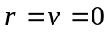 at t=0 5
4. a. Calculate 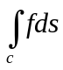
Where f=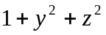, c: 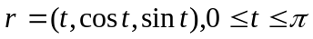 7
b. Find the work done in moving a particle in the force field
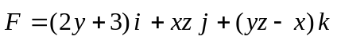 along the curve x=2t², y=t, z=t³ from the point (0,0,0) to (2,1,1). 8
OR
Show that the value under integral sign
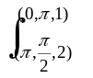(-zsinh xz dx +cosy dy-xsinxz) is exact and evaluate the integral.
5. Solve 2.5x2=5
i) If A=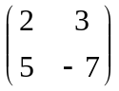 show that (A²)^{t}=(A^{t})²
ii) Find the angle between the tangents to the curve
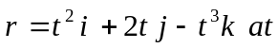 the points t=

